*Modulation Classification*

**Name : Jamal El Din Ahmed Khalaf**

**ID : 15**

**Name : Hazem Morsy Hassan**

**ID : 16**

**Description :**

It is required to classify input signals into ten different modulations by using five different classifiers which are logistic regression , Decision Tree , Random Forest , Fully connected layer and convolutional neural networks. Data is saved in form of .dat file in which it is represented as a map that has key as a pair of (modulation , signal to noise ratio) and the value is the samples that belong to this key in which each sample has two channels and each channel has 128 features ,so each sample has a shape of (2 , 128).

**Data representation and Data split:**

We represented data by four different features :

* Raw data (data found in .dat file without any modifications)
* Derivative of Raw data (using xi = [x(i-1) + x(i+1)] / 2 )
* Integral of Raw Data (using the cumulative sum)
* Combination of Raw , Derivative and integral data (6 channels)

Label of each sample is a pair of (modulation , SNR).

After getting the features of data by any of above methods ,we split data as follows :

* 70 % for training
* 5% of training data for validation
* 30% for testing

**Results :**

Generally , Accuracy improves for higher SNR as the signal overcomes the noise in it.

* ***Logistic Regression:***

Validation accuracy : 15.98 %

Test accuracy : 16 %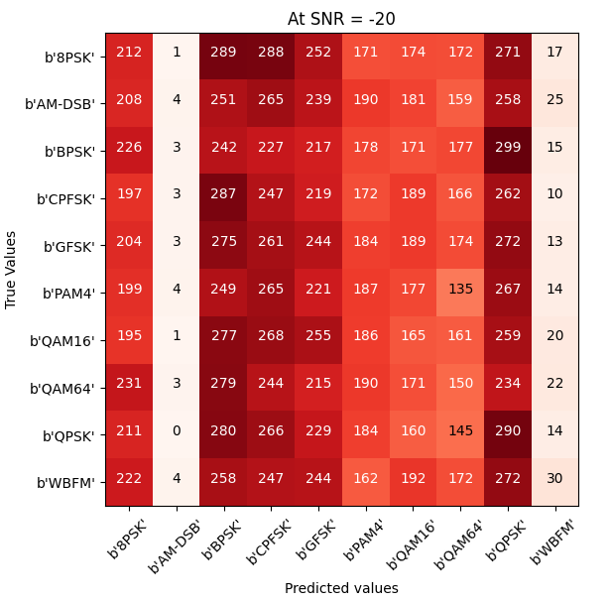

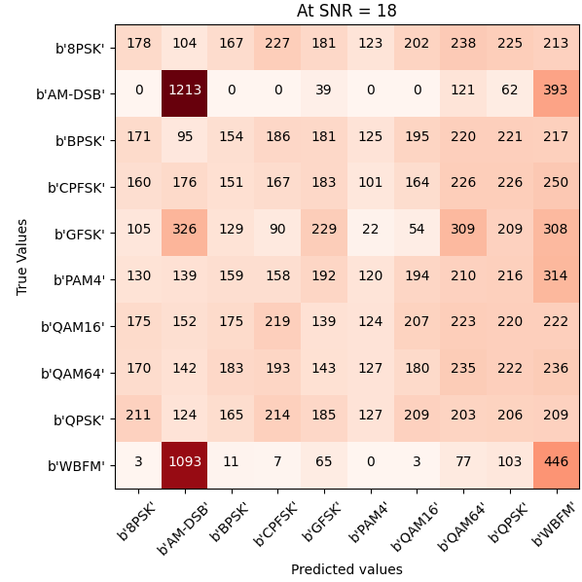

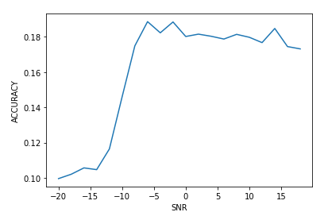



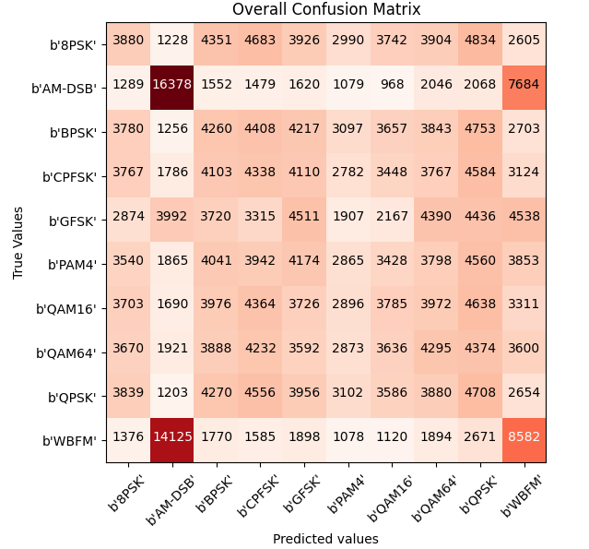





The Most confusing classes are (AM-DSB , WBFM)

* **Decision Tree:**

Validation accuracy : 32 %

Test accuracy : 32.27 %

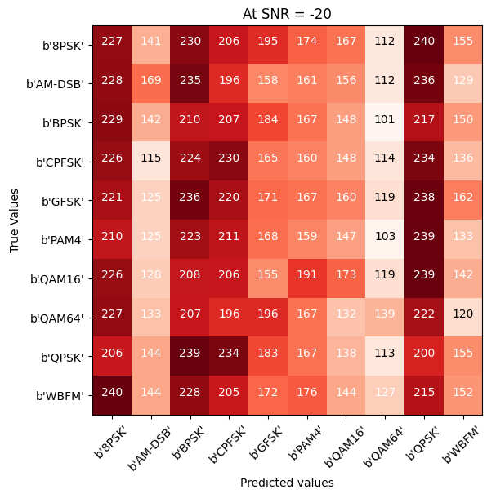

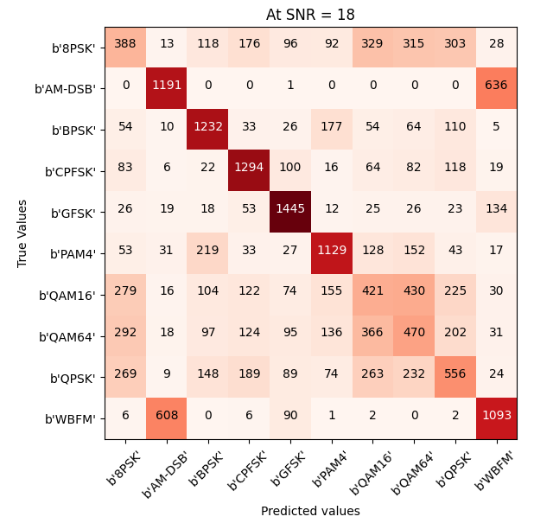

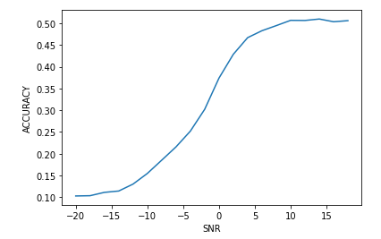



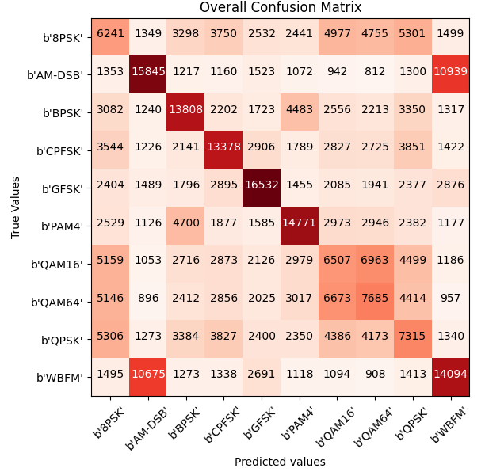





The Most Confusing classes (QAM16 , QAM64)

* **Random Forest:**

Validation accuracy : 43.3 %

Test accuracy : 43.7 %

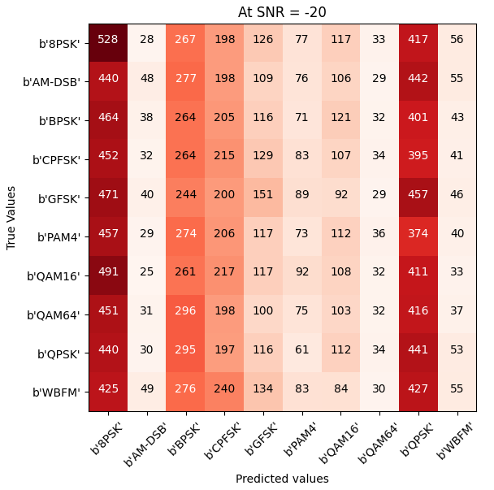

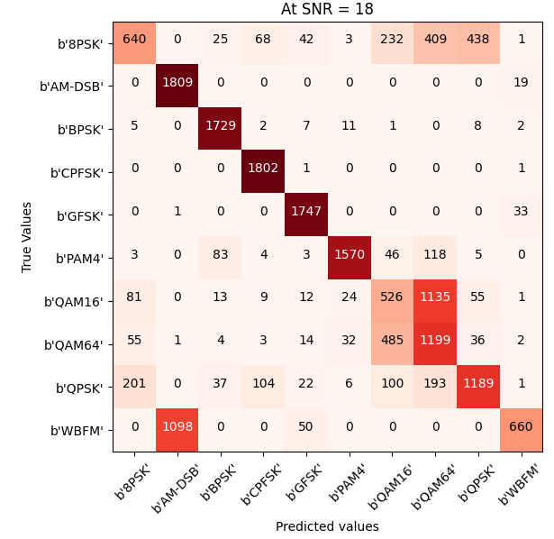

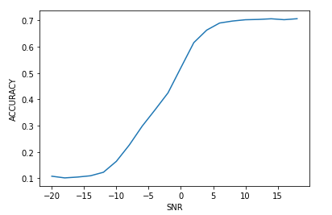



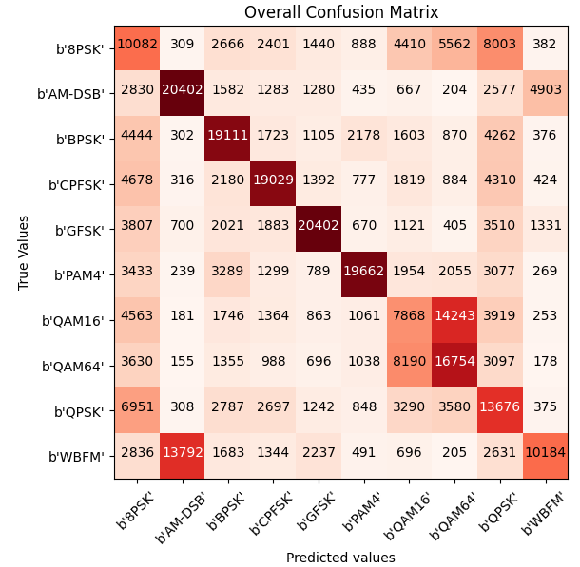





The Most Confusing classes (QAM16 , QAM64)

**Fully Connected Layer :**

Validation accuracy : 48 %

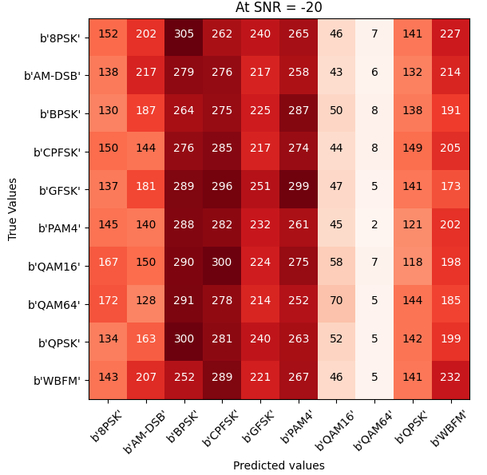

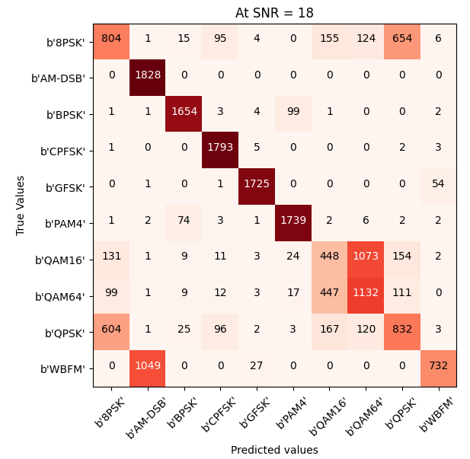

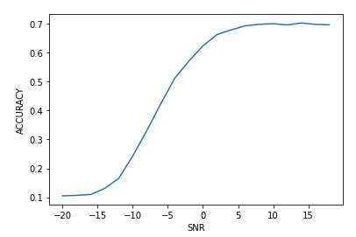



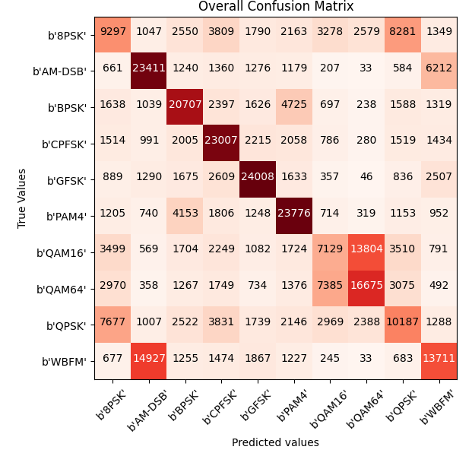





The Most Confusing classes (QAM16 , QAM64)

**CNN:**

Validation accuracy : 58%

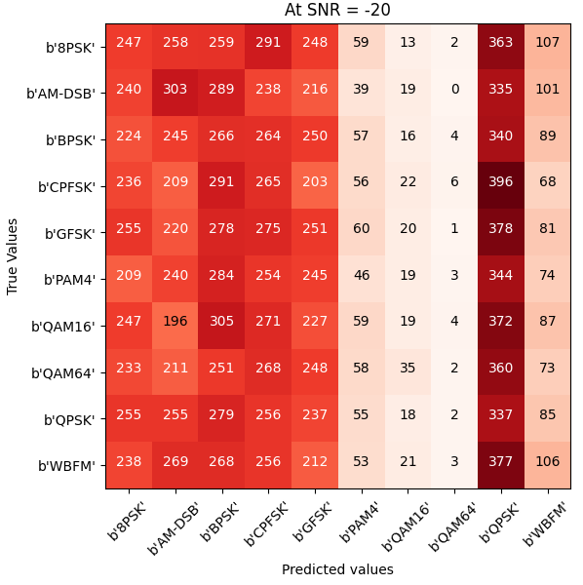

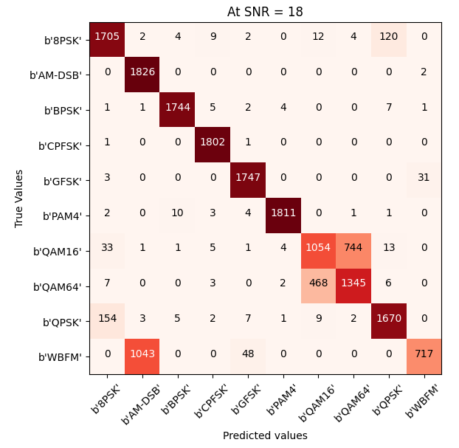

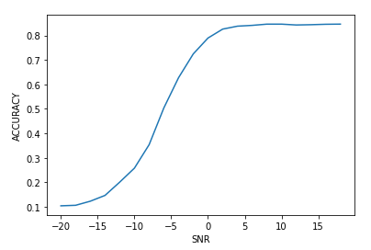



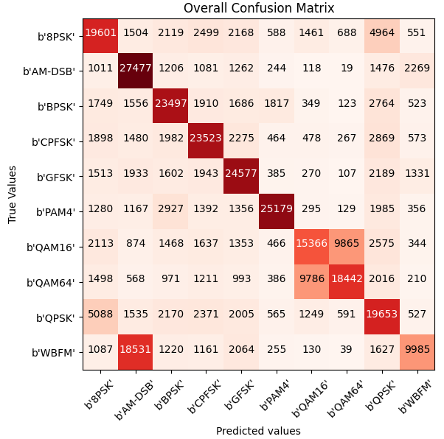





The Most Confusing classes (QAM16 , QAM64)